**Electric Charges and Fields**

**1 Introduction. 2 Electric Charge. 3 Conductors and Insulators. 4 Charging by Induction. 5 Basic properties of electric charges. 6 Coulomb’s law. 7 Force between multiple. ……………………………………………………………………………………………………………………………………………………………………………………………………**

**Introduction**

**In 600 B.C., *Thales of Miletus*, one of the founders of Greek science, first noticed that if a piece of amber is rubbed with a woolen cloth, it then acquires the property of attracting light feathers, dust, lint, pieces**

**Of leaves, etc. In 1600 A.D., *William Gillbert*, the personal doctor to *Queen Elizabeth*- I of England, made a systematic study of the substance that behaves like amber. In his book *De Magnete* (on the magnet), he introduce the name electrica for such substance. In fact, the Greek name for amber is electron, which is the origin of all such words: electricity, electric force, electric charge and electron.**

**Fractional electricity**

**If a glass rod is rubbed with a silk cloth, or a fountain-pen with a coat- sleeve, it is able to attract small pieces of paper, straw, lint, light feathers, etc. Similarly, a plastic comb passed through dry hair can attract such light object. In all these examples, we can say that the rubbed substance has become *electrified or electrically charged*. It is because of friction that the substance gets charged on rubbing. The property of rubbed substance due to which they attract light object is called electricity. The electricity developed by rubbing or friction is called frictional or static electricity. The rubbed substance which shows this property of attraction are said to have become electrified or electrically charged.**

**Electrostatic:-The branch of physics which deals with the study of electric force electric field, Electric potential and electric energy due to charge are at rest is known as electrostatic .It is also known as static electricity.**

**Application of Electrostatic**

**In electrostatic loud-speakers, in electrostatic spraying for paints and powder coating, in fly ash collection in chimneys, in a photo copy machine, Electric capacitor or condensers, in the design of a cathode-ray tube used in television and radar. Natural phenomenon like lightning and thundering.etc**

**Electric charge**

**Electric charge is a physics property of matter that causes it to experience a force when placed in electromagnetic fields. Electric charge is a physical quantity which causes electric force in a matter.**

**It is a scalar quantity.**

**Its SI unit is coulomb(C).**

**It’s dimensional formula [AT-1] or [M0 L0 T-1 A1].**

**A proton has a positive a positive charge (+e) and an electron has a negative charge (-e),**

**where [e= 1.6 × 10-19 coulomb]**

**Positive and Negative Charges**

***Benjamin Franklin* (1706-1790), an American pioneer of electrostatics introduced the present day convention by replacing the terms vitreous and resinous by positive and negative charges, respectively. According the convention:**

**1.The charge developed on a glass rod when rubbed with silk is called positive charge.**

**2.The charge developed on a plastic rod when rubbed with wool is called negative charge.**

**The above convention is consistent with the fact that when two opposite kinds of charge are brought in contact, they tend to cancel each other’s effect. According to this convention, *the charge on an electron is negative.***

**Given a list of the pairs of objects which get charged on rubbing against each other . On rubbing an object of column 1 will acquire positive charge while that of column II will acquire negative charge.**

|  |  |
| --- | --- |
| **Column I** | **Column II** |
| **(Positive Charge)** | **( Negative Charge)** |
| **Glass rod** | **Silk Cloth** |
| **Flannel or cat skin** | **Ebonite rod** |
| **Woolen cloth** | **Amber rod** |
| **Woolen coat** | **Plastic seat** |
| **Woolen carpet** | **Rubber shoes** |

**Obviously, any two charged objects belonging to the same column will repel each other while those of two different columns will attract each other.**

**ELECTRONIC THEORY OF FRICTIONAL ELECTRICITY**

**All matter is made of atoms. An atom consists of a small central nucleus containing protons and neutrons, around which revolve a number of electrons. In any piece of matter, the positive proton charges and the negative electron charges cancel each other and so the matter in bulk is electrically neutral.**

**The electrons of the outer shell of an atom are loosely bound to the nucleus. The energy required to remove an electron from the surface of a material is called its 'work function'. When two different bodies are rubbed against each other, electrons are transferred from the material with lower work function to the material with higher work function. For example, when a glass rod is rubbed with a silk cloth, some electrons are transferred from glass rod to silk. The glass rod develops a positive charge due to deficiency of electrons while the silk cloth develops an equal of negative charge due to excess of electrons. The combined total charge of the glass rod and silk cloth is her still zero, as it was before rubbing i.e., electric charge is low conserved during rubbing.**

**Electric origin of the frictional force**

**The only way by which an electron can be pulled away from an atom is to exert a strong electric force on It. Electrons are actually transferred from one body to another during rubbing, so frictional forces must have an electric origin.**

**CONDUCTORS AND INSULATORS**

**Conductors = S*ubstances through which electric charges can flow easily are called conductors*. They contain a large number of free electrons which make them good conductor of electricity. Metals, human and animal bodies, graphite, acids, alkalies, etc. are conductors.**

**Insulators = *The substances through which electric charges c cannot flow easily are called insulators*. In the atoms of such substances, electrons of the outer shell are tightly bound to the nucleus. Due to the absence of free charge carriers, these substances offer high resistance to the flow of electricity through them. Most of the non-metals like glass, diamond, porcelain, plastic; nylon, r wood, mica, etc. are insulators.**

**An important difference between conductors and insulators is that when some charge is transferred to a conductor, it readily gets distributed over its entire surface. On the other hand, if some charge is put on an insulator, it stays at the same place.**

**A metal rod held in hand and rubbed with wool does not develop any charge. This is because the human body is a good conductor of electricity, so any charge developed on the metal rod is transferred to the earth through the human body. We can electrify rod by providing it a plastic or a rubber handle and rubbing it without touching its metal part.**

**Ear-thing and safety**

**When a charge body is brought in the contact with earth (through a connecting conductor) its entire charge passes to the ground in the form of a momentary current. *This process in which a body shares its charges with the earth is called grounding or earthing.***

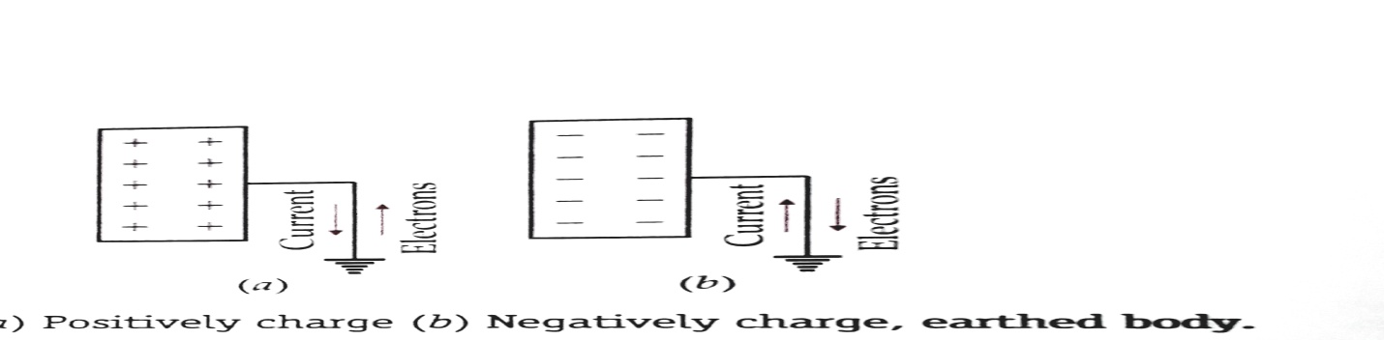

**The electricity from the mains is supplied to our houses using a three-core wiring: *live, neutral* and *earth wires*. The live wire red in color brings in the current. The black neutral wire is the return wire. The green earth wire is connected to a thick metal plate buried deep into the earth. The metallic bodies of the electric appliances such as electric iron, refrigerator, TV, etc. are connected to the earth wire. When any fault occurs or live wire touches the metallic body, the charge flows to the earth and the person who happens to touch the body of the appliance does not receive any shock.**

**ELECTROSTATIC INDUCTION**

**As shown in the Figure conducting rod *AB* over an insulating stand. Bring a positively charged glass rod near its end *A*. The free electrons of the conducting rod get attracted towards the end *A* while the end *B* becomes electron deficient. The closer end *A* acquires a negative charge while the remote end *B* acquires an equal positive charge. As soon as the glass rod is taken away, the charges at the ends *A* and *B* disappear.**

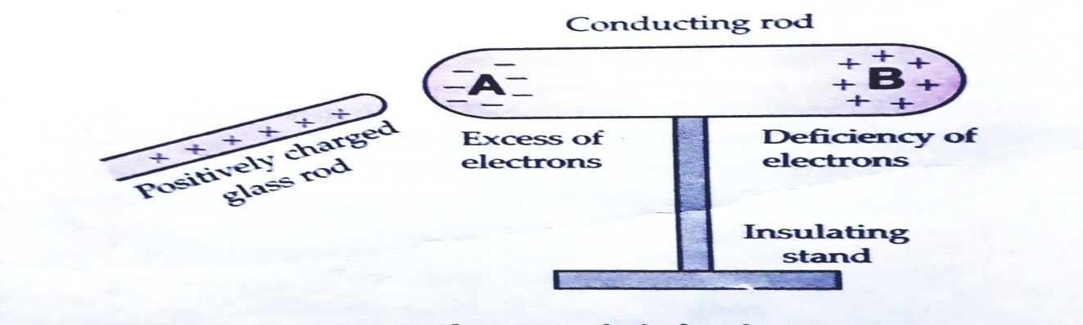

**Electrostatic induction**

***Electrostatic induction* *is the phenomenon of temporary electrification of a conductor in which opposite charges appears at its closer end and similar charges appear at its farther end in the presence of a nearby charged body.***

**The positive and negative charges produced at the ends of the conducting rod are called *induced charges* and the charge on the glass rod which induces these charges on conducting rod is called *inducing charge*.**

**Charging of the two spheres by induction**

**In the given figure shows the various steps involved in inducing opposite charges on two metal spheres.**

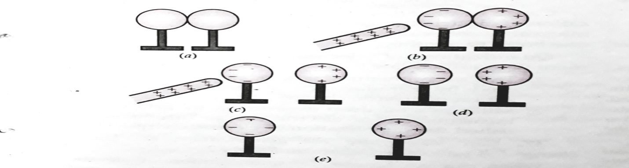

**(a) Holds the two metal spheres on insulating stands and place them in contact, as shown in the figure (a).**

**(b) Bring a positively charged glass rod near the lift sphere. The free electrons of the spheres get attracted towards the grass rod. The left surface of the lift sphere develops an excess of negative charge while the right side of the right sphere develops an excess of positive charge. However, all of the electrons of the spheres do not collect at the left face. As the negative charge begins to build up at the left face, it starts repelling the new incoming electrons. So their equilibrium is established under the action of force of attraction of the rod and the force of repulsion due to the accumulated electrons. The equilibrium situation is shown in above Figure (b).**

**(c) Holding the glass rod near the left sphere, separate the two spheres by a small distance, as shown in Figure (c). The two spheres now have opposite charges.**

**(d) Remove the glass rod. The charges on the spheres get redistributed. Their positive and negative charges face each other, as shown in Figure (d). The two the spheres attract each other.**

**(e) When the two spheres are separated quite apart, the charges on them get uniformly distributed, as re shown in Figure (e).**

**Thus the two metal spheres get charged by a process called *charging by induction*. In contrast to the process of charging by contact, here the glass rod does not lose any of its charge.**

**Charge a sphere by induction**

**Shows suite the various steps involved in inducing a positive charge on a metal sphere.**

**(a)-Hold the metal sphere on an insulating stand. Bring a negatively charged plastic rod near it. The free electrons of the sphere are repelled to the farther end. The near end becomes positively charged due to deficit of electrons.**

**(b)-When the far end of the sphere is connected to the ground by a connecting wire, its free electrons flow to the ground.**

**(c)-When the sphere is disconnected from the ground, its positive charge at the near end remains held there due to the attractive force of the external charge.**

**(d)-When the plastic rod is removed, the positive charge spreads uniformly on the sphere.**

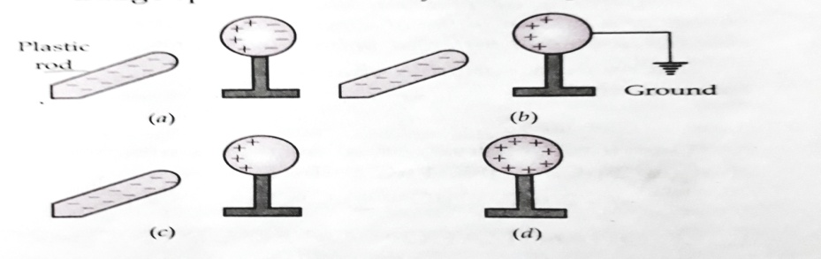

**Charging by induction**

**Similarly, the metal sphere can be negatively charged by bringing a positively charged glass rod.**

**It is observed from experiments that electric charge has following *three* basic properties**

1. **Additivity 2. Quantization 3. Conservation.**

**ADDITIVITY OF ELECTRIC CHARGE**

**Like mass, electric charge is a scalar quantity. Just as the mass of an extended body is the sum of the masses of its individual particles, the total charges of an extended body is the algebraic sum (i.e., the sum taking into account the positive and negative signs) of all the charges located at different points inside it. Thus, the *electric charge is additive in nature*.**

**Additive of electric charge *means that the total charge of a system is the algebraic sum of all the individual charges located at different points inside the system.***

**If a system contains charges *q*1, *q*2,*……………….,q*n , then its total charges is**

**q=q1 +q2+ ……………………. + qn**

**The total charge of a system containing four charges 2µC, -3 µC, 4 µC and - 5 µC is**

**q=2 µC -3 µC +4 µC -5 µC =-2 µC.**

**QUANTIZATION OF ELECTRIC CHARGE**

**Quantization of a physical quantity**

***The quantization of a physical quantity means that it cannot vary continuously to have any arbitrary value but it can change discontinuously to take any one of only a discrete set of values*. For example, a building can have different floors (ground, first, second, etc.) from the ground floor upwards but it cannot have a floor of the value in-between. Thus the energy of an electron in atom or the electric charge of a system is quantized. *The minimum which a physical quantity can change is called quantum.***

**Quantization of electric charge**

**It is found experimentally that the electric charge of any body, large or small, is always an integral multiple of a certain minimum amount of charge. This basic charge is the charge on an electron, which is denoted by e and has magnitude1.6 x 10-19coulomb. Thus the charge on an electron is - e, on a proton is + e and that on a-particle is +2e.**

***The experimental fact that electric charges occur in discrete amounts instead of continuous amounts is called quantization of electric charge. The quantization of electric charge means that the total charge (q) of a body is always an integral multiple of a basic quantum of charge (e), i.e.,***

***q=ne*, where n=0, ±1, ± 2, and ± 3 ….**

**Cause of quantization**

**The basic cause of quantization of electric charge is that during rubbing only an integral number of electrons can be transferred from one body to another.**

**Quantization of electric charge is an experimentally verified law:**

**1. The experimental laws of electrolysis discovered, by Faraday first suggested the quantization of electric charge. 2. Millikan's oil drop experiment in 1912 on the measurement of electric charge further established the quantization of electric charge.**

**When we can ignore the quantization of electric charges**

**While dealing with macroscopic charges (*q = ne*), we can ignore the quantization of electric charge. This is because the basic charge e is very small and n is very large in most practical situations, so *q* behaves as if it were continuous *i.e*., as if a large amount of charge were flowing. For example, when we switch on a 60 W bulb, nearly 2 x 1018 electrons pass through its filament per second. Here the graininess or structure of charge does not show up *i.e*., the bulb does not flicker with the entry of each electron. Quantization of charge becomes important at the microscopic level, where the charges involved are of the order of a few tens or hundreds of *e*.**

**Gold-leaf electroscope**

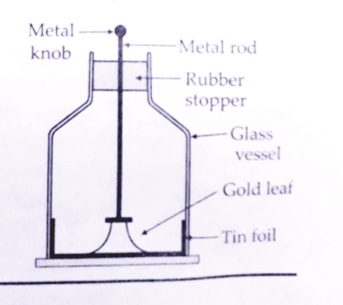

**It is a device used for detecting an electric charge and identifying its polarity. It consists of a vertical conducting rod passing through a rubber stopper fitted in the mouth of a glass vessel. Two thin gold leaves are attached to lower end of the rod. When a charged object touches the metal knob at the outer end of the rod, the charge flows down to the leaves. The leaves diverge due to repulsion of the like charges they have received. The degree of divergence of the leaves gives a measure of the amount of charges.**

**Conservation of charge**

**If some amount of matter is isolated in a certain region of space and on matter either enter or leave this region by moving across its boundary, then whatever other Charges may occur in the matter inside its total charge will not change with time. This is the *law of conservation of charge which states: 1. the total charge of an isolated system remains constant. 2. The electric charges can neither be created nor destroyed; they can only be transferred from one body to another.*  The law of conservation of charge is obeyed both in large scale and microscopic processes. In fact, charge conservation is a global phenomenon *i.e., total charge of the entire universe remains constant*.**

**Examples**

**1. When a glass rod is rubbed with a silk cloth, it develops a positive charge. But at the same time, the silk cloth develops an equal negative charge. Thus the net charge of the glass rod and the silk cloth is zero, as it was before rubbing. 2. The rock-salt ionizes in aqueous solution as follows:**

**Nacl= Na+ + cl- As the total charge is zero before and after the ionization, so charge is conserved.**

**3. Charges are conserved during the fission of 23592U nucleus by a neutron.**

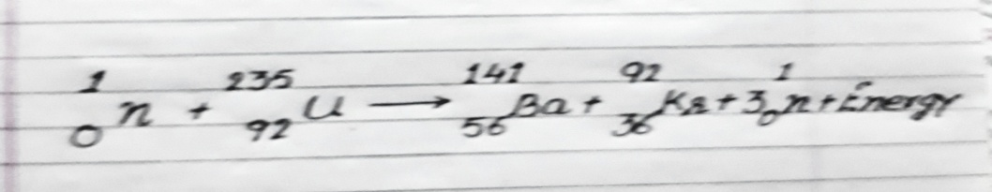

**Total charge before fission (0+92) =Total charge after fission (56+36+3×0).**

**4. Electric charges are conserved during the phenomenon of *pair production in which a ϒ-ray photon materializes into an electron- proton pair.***

**ϒ -ray → electron + positron. Zero charge (-e) (+e)**

**5. In *annihilation of matter*, an electron and a positron on coming in contact destroy each other, producing two Y-rays photons, each of energy 0.51 Me V.**

**Electron + positron = 2Y-rays**

**(-e) (+e) zero charge**

**Comparison of the properties of electric charge and mass**

|  |  |  |  |  |  |  |  |  |  |  |  |  |  |  |
| --- | --- | --- | --- | --- | --- | --- | --- | --- | --- | --- | --- | --- | --- | --- |
|  | **Electric charge** | | | |  |  |  | | | **Mass** |  |  |  |  |
| **1** | **Electric charges may be positive, negative or zero** | | | | | | | **Mass of a body is always positive.** | | | |  | | |
| **2** | **Electric charges is always quantized: q=ne** | | | | |  | **Quantization of mass is not yet established.** | | | | | |  |  |
| **3** | **Charge on a body does not depend on its speed.** | | | | | | | **Mass of a body increases with its speed.** | | | |  |  |  |
| **4** | **Charge is strictly conserved.** | | |  |  |  | **Mass is not conserved by itself as some of the mass** | | | | | | |  |
|  |  | | | | | | | **may get changed into energy or vice versa.** | | | |  |  |  |
| **5** | **Electrostatic forces between two charges may be attractive or** | | | | | | | **Gravitational force between two masses are** | | | | | |  |
|  | **repulsive** | | | | | | | **always attractive.** | | | | | |  |
| **6** | **Electrostatic forces between different charges may cancel** | | | | | | | **Gravitational forces between different bodies** | | | | | |  |
|  | **out.** | | | | | | | **never cancel out.** | | | | | |  |
| **7** | **A charge body always possesses some mass.** | | | | | | | **A body possessing mass may not have any net** | | | | | |  |
|  |  | | | | | | | **Charges.** | | | | | |  |
|  |  | | | | | | |  | | | | | |  |
|  |  |  |  |  |  |  | |  |  |  |  |  |  |  |
|  |  |  |  |  |  |  | |  |  |  |  |  |  |  |
|  |  |  |  |  |  |  | |  |  |  |  |  |  |  |
|  |  |  |  |  |  |  | |  |  |  |  |  |  |  |
|  |  |  |  |  |  |  | |  |  |  |  |  |  |  |

**Effect of speed on mass and electric charge**

**According to the special theory of relativity, the mass of a body increases with its speed in according with the relation:**



**Where, m0 = rest mass of the body, c = speed of light, and m = mass of the body when moving with speed v.**

**As v < c therefore m > m0 . In contrast to mass, the charge on a body remains constant and does not change as the speed of the body changes.**

**COULOMB’S LAW OF ELECTRIC FORCE**

**Coulomb's law**

**In 1785, the French physicist *Charles Augustin Coulomb* (1736-1806) experimentally measured the electric forces between small charged spheres by using a torsion balance. He formulated his observations in the form of Coulomb's law which is electrical analogue of Newton's law of Universal with Gravitation in mechanics.**

***Coulomb's law states that the force of attraction or repulsion between two stationary point charges is (i) directly proportional to the product of the magnitudes of the two charges and (ii) inversely proportional to the square of the distance between them. This force acts along the line joining the two charges*.**

***q1  ← r → q2***

**●--------------------------------------------------------●**

**Coulomb’s law**

**If two point charges *q1* and *q2* are separated by distance *r*, then the force *F* of attraction or repulsion between them is such that.**

***F $α$ $q_{1}$ $q_{2}$ and $F α\frac{1}{r^{2}}$***

$∴$***F $α$ $\frac{q_{1}q_{2} }{r^{2}}$ or F=k $\frac{q_{1}q_{2} }{r^{2}}$***

**Where *k* is *electro-static force constant*, the value of *k* depends on the nature of the medium between the two charges and the system of units chosen to measure *F, q1, q2,* and *r*.For the two charges located in free space and in SI units, we have**

***k = Nm2 c-2* where εo is called *permittivity* of free space. So we can express Coulomb's law in SI units as**

***F = $\frac{\text{1}}{\text{4π}{\text{ε}}_{\text{0}}}$ $\frac{q_{1}q_{2} }{r^{2}}$***

**Units of charge**

**(i) *The SI unit of charge is coulomb*. In the above equation, if $q_{1}$ = $q_{2}$ =1 C and *r* =1m, then**

***F = $\frac{1}{4πε_{0}}=9x{10}^{9 }N$*  *So one coulomb is that amount of charge that repels an equal and similar charge with a force of 9× ${10}^{9}$ N when placed in vacuum at a distance of one meter from it.***

**(ii) In electrostatic cgs system, the unit of charge is known as *electrostatic unit of charge* (e.s.u. of charge) or *stat-coulomb* (stat C).**

***One e.s.u. of charge or one stat-coulomb is that charge which repels an identical charge in vacuum at a distance of one centimeter from it with a force of 1 dyne.***

**1 coulomb = 3 x ${10}^{9}$ statcoulomb**

**= 3 x ${10}^{9}$ e.s.u. of charge**

**(iii) In electromagnetic cgs system, the unit of charge is *abcoulomb* or *electromagnetic unit of charge* (e.m.u. of charge).**

**1 coulomb = $\frac{1}{10}$ abcoulomb**

**= $\frac{1}{10}$ e.m.u. of charge**

**COULOMB’S LAW IN VECTOR FORM**

**Consider two positive point charges *q* and *q* placed in vacuum at distance *r* from each other. They repel each other.**

**͢ + q1 ← r → +q2 ͢ 12←──●----------------------------------●──────→21**

**ȓ12 → ← ȓ21**

**Repulsive combination forces for q1 q2 > 0.**

**In vector form coulomb’s law may be expressed as**

**͢  21 = force on charge q2 due to q 1**

***=*  ȓ12**

**Where ȓ12 = , is a unit vector in the direction from *q 1 to q2.***

**similarly  ͢  .12 = force on charge *q1* due to *q2***

**= ȓ21**

**Where ȓ21 = , is a unit vector in the direction from *q2*to *q1*.**

**The Colombian forces between unlike charges (*q1 q2 <0*) are attractive, as given in below**

**+q1 ← r → -q2 . ȓ12 ●──────→----------------←──────● r21**

**͢  ͢   .12----------------→ ←----------- 21**

**Attractive combination forces for q1q2*<* 0.**

**Importance of vector form**

**The vector form of coulomb’s law gives the following additional information.  1. As ȓ12 = - ȓ12 , therefore $\vec{F_{21}}$ = $\vec{F_{12}}$.**

**This means that the two charges exert equal and opposite forces on each other. So *Coulombian forces obey Newton’s third law of motion.***

**2. As the coulombian forces act along $\vec{F_{12}}$ or $\vec{F_{21}}$ i.e., along the line joining the centers of two charges, so they are *central force*.**

**Range of coulombian forces**

**Coulombian forces acts over an enormous range of separation (r ), from nuclear dimension( r== 10-15 m) to macroscopic distance as large as 1018 m. Inverse square law is valid over this range of separation to a high degree of accuracy.**

**Limitation of coulomb’s law**

**Coulomb’s law is not applicable in all situations. It is valid only under the following condition:**

**1. The electric charge must be a rest.**

**2. The electric charge must be point charge i.e., the extension of charge must be much smaller than the separation between the charges.**

**3. The separation between the charges must be greater than the nuclear size (10-15 ), because for distance <10-15m, the strong nuclear force dominates over the electrostatic force.**

**DIELECTRIC CONSTANT AND RELATIVE PERMITTIVITY**

**Permittivity: an introduction**

**When two charges are placed in any medium other than air, the force between them is greatly affected*. Permittivity is a property of the medium which determines the electric force* *between two charges situated in the medium*. For example, the force between two charges located some distance apart in water is about $1/{{80}^{th}}$ of the force between them when they are separated by some distance in air. This is because the absolute permittivity of water is about 80times greater than the absolute permittivity of air or free space.**

**Dielectric constant or relative permittivity**

**According to coulomb’s law, the force between two point charges *q1*and *q2* placed in vacuum at distance *r* from each other, is given by**

**fvac *=* ...................................... (1)**

**When the same two charges are placed same distance apart in medium other than vacuum, the force between them becomes**

**fmed *=* ............................................ (2)**

**The quantity ɛ is called *absolute permittivity* or just permittivity of the intervening medium. Dividing equation (1) by equation (2), we get**

$\frac{ fvac}{ fmed }= \frac{\frac{\text{1}}{\text{4π}{\text{ε}}_{\text{0}}}}{\frac{1}{4π\text{ε}k}} \frac{\frac{q_{1}q_{2} }{r^{2}}}{\frac{q_{1}q_{2} }{r^{2}}} = \frac{ ɛ}{{ ɛ}_{0}}$

***The ratio ${( ɛ}/{{ ɛ}_{0}})$ of the permittivity $(ɛ)$ of the medium to the permittivity ( ${ ɛ}_{0})$ of free space is called relative permittivity ( $ɛ_{r}$) or dielectric constant ( k ) of the given medium. Thus***

$ɛ_{r}$**Or k = $\frac{ ɛ}{{ ɛ}_{0}}=$ $\frac{ fvac}{ fmed }$ = $\frac{1}{4π\text{ε}k}$**

**So one can define dielectric constant in terms of force between charges follows:**

***The dielectric constant or relative permittivity of a medium may be define as the ratio of the force between two charges placed some distance apart in free space to the force between the same two charges when they are placed the same distance apart in the given medium*.**

**Clearly, when a material medium of dielectric constant k is placed between the charges, the force between them becomes $1/k$ times the original force in vacuum. That is**

**fmed =**

**Hence the coulomb’s law for any material medium may be written as**

**fmed =**

**k (vacuum ) = 1**

**k (air) = 1.00054**

**k (water ) =80**

**COMPARING ELECTROSTATIC AND GRAVITATIONAL FORCES**

**Electrostatic forces gravitational force. Electrostatic is the force of attraction or repulsion between two charges at rest while the gravitational force is the force of attraction between two bodies by virtue of their masses.**

**Similarities:**

**1. Both forces obey inverse square law i.e.,**

**F α $\frac{1}{r^{2}}$**

**2. Both forces are proportional to product of masses or charges. 3. Both are *central forces* i.e., they act along the line joining the centre of the two bodies. 4. Both are *conservative forces i.e*., the work done against these forces does not depend upon the path Followed.   
5. Both forces can operate in vacuum.**

**Dissimilarities**

**1. Gravitational force is attractive while electrostatic force may be attractive or repulsive.**

**2. Gravitational force does not depend on the nature de of the medium while electrostatic force depends on the nature of the medium between the two charges.**

**3. Electrostatic forces are much stronger than gravitational forces.**

**Illustrative Problem**

***Coulomb's law for electrical force between two charges and Newton's law for gravitational force between two masses, both have inverse-square dependence on the distance between charges/masses*.**

***(a) Compare the strength of these forces by determining the ratio of their magnitude. For an electron, a proton and for two protons.***

***(b) Estimate the accelerations for electron and proton due to the electrical force of their mutual attraction when they are 1 A0 (A0* *=10) apart*.**

**(a)**

**(i) From *Coulomb's* law, the electrostatic force between an electron and a proton separated by distance r is**

**Fe = *k $\frac{q_{1}q_{2}}{r^{2}}$*  = $k \frac{\left(+e\right)(-e)}{r^{2}}$ = $-k\frac{e^{2}}{r^{2}}$**

**Negative sign indicates that the force is attractive. From Newton's law of gravitation, the corresponding gravitational attraction is**

**FG  = -G $\frac{m_{p} m_{e}}{r^{2}}$**

**Where mass of proton (mp) and mass of electron (me).**

**Hence**

**| | =**

**But k =9 x 109 Nm2C-2, e =1.6 x 10-19 C,**

**mp = 1.67 x 10-27 kg, me =9.1 x 10-31 kg,**

**G = 6.67 x 10-11 Nm2 kg-2**

**| =**

**= 2.271039**

**(a). (ii) Similar to that in part (i), the ratio of the magnitudes of electric force to the gravitational force between two protons at a distance r is given by**

**=**

**=**

**= 1.241036**

**Thus the large value of the (dimensionless) ratio of the two forces indicates that the electrostatic forces are enormously stronger than the gravitational forces.**

**(b). The magnitude of the electric force exerted by a proton on an electron is equal to the magnitude of the force exerted by an electron on a proton. The magnitude of this force is**

**F =**

**F= [ r= 1A0 =10-10 m]**

**F= 2.310-8 10-8N**

**Acceleration of a electron due to the mutual attraction with the proton.**

**ae =**

**ae =**

**ae= 2.5 102 ms-2**

**Acceleration of the proton due to the mutual attraction with the electron,**

**ap =**

**ap=**

**ap = 1.3 1019 ms-2**

**Clearly, the acceleration of an electron or a proton due to the electric force is much larger than the acceleration due to gravity. So, we can neglect the effect of gravitational field on the motion of the electron or the proton.**

**Electrical force is enormously stronger than the gravitational forces**

**(i) A plastic comb passed through hair can easily lift a piece of paper upwards. The electrostatic attraction between the comb and the piece of paper overcomes the force of gravity exerted by the entire earth on the paper.**

**(ii) When we hold a book in our hand, the electric (frictional) forces between the palm of our hand and the book easily overcome the gravitational force on the book due to the entire earth.**

**In the words of Feynman, if you stand at arm's length from your friend and instead of being electrically neutral each of you had an excess of electrons over protons by just *one per cent*, then the force of the repulsion between you would be enough to lift the entire earth.**

**FORCES BETWEEN MULTIPLE CHARGES: THE SUPERPOSITION PRINCIPLE**

**Principle of superposition of electrostatic forces**

**Coulomb's law gives force between two point charges. The principle of superposition enables us to find the force on a point charge due to a group of point charges. This principle is based on the property that the forces with which two charges attract or repel each other are not affected by the presence of other charges.**

***The principle of superposition states that when a numbers of charges are interacting, the total force on a given charge is the vector sum of the forces exerted on it due to other charges. The force between two charges is not affected by the presence of other charges*.**

**As shown in Figure, consider N point charges *q1,q2,q2, ........................... ,qN* placed in vacuum at points whose position vectors w.r.t. origin 0 are** **, , ,………… N respectively.**

**According to the principle of superposition, the total force on charge *q1* is given by.**

**= + +………………………….+**

**Where $\overset{→}{F_{1}}$ $,\overset{→}{F_{12}}$ , $\overset{→}{F_{13}}$, …………………………. $, \overset{→}{F_{1N}}$ are the forces exerted on charge *q1* by the individual charge *q2,q2,……qN* respectively.**

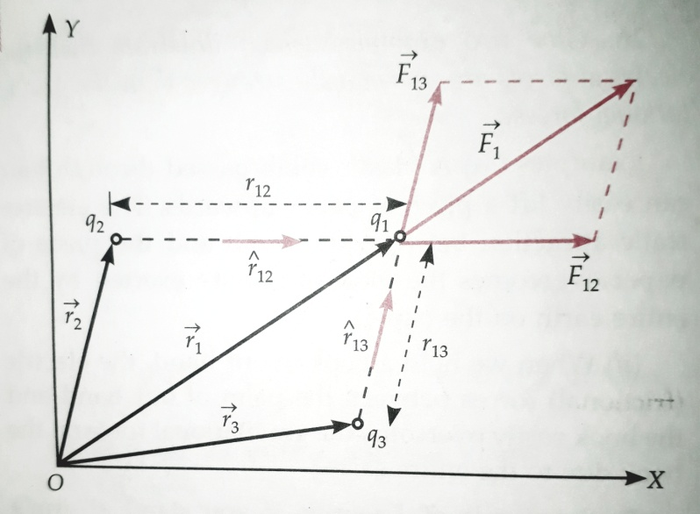

**Superposition principle: Force on charge q1 exerted by q2 and q3.**

**According to Coulomb's law, the force exerted on charge q1 due to q2**

**=  ȓ12**

**.**

**=  q1q2**

**Where ȓ12 =  *= a* unit vector pointing from q2to q1and ȓ12 =| | =distance of q2 from q1.**

**Hence the total force on charge is**

**= [ ȓ12 + ȓ13 +………………………. + ȓ1N]**

**= ȓ1i**

**In term of positive vectors**

$\overset{→}{F_{1}}$**= $\frac{\text{1}}{\text{4π}{\text{ε}}_{\text{0}}}$ $\left[q_{1}q_{2} \frac{\begin{matrix}\overset{→}{r_{1}} & - & \overset{→}{r_{2}}\end{matrix}}{\begin{matrix}\overset{→}{(r_{1}} & - & \overset{→}{r_{2 )3}}\end{matrix}}+q_{1 } q_{3} \frac{\begin{matrix}\overset{→}{r_{1}} & - & \overset{→}{r_{3}}\end{matrix}}{\begin{matrix}\overset{→}{(r_{1}} & - & \overset{→}{r_{3 )3}}\end{matrix}}+ ……+q_{1} q_{N} \frac{\begin{matrix}\overset{→}{r_{1}} & - & \overset{→}{r_{N}}\end{matrix}}{\begin{matrix}\overset{→}{(r_{1}} & - & \overset{→}{r_{N )3}}\end{matrix}} \right]$**

$\overset{→}{F_{1}}$**= $\frac{q_{1}}{\text{4π}{\text{ε}}_{\text{0}}}$ $\sum_{i=2}^{N}{q_{i}}$ $\frac{\begin{matrix}\overset{→}{r_{1}} & - & \overset{→}{r_{i}}\end{matrix}}{\begin{matrix}\overset{→}{(r_{1}} & - & \overset{→}{r_{i )3}}\end{matrix}}$**

**In general, force $\overset{→}{F_{a}}$ on *ath* charge qa located at $\overset{→}{r_{a}}$ due to all other (N-1) charges may be written as**

$\overset{→}{F_{a}}$**=Total force on *ath* charge**

$\overset{→}{F}$**= $\frac{q_{a}}{\text{4π}{\text{ε}}_{\text{0}}}$ $\sum_{\begin{matrix}b & = & 1 \\ b & ≠ & a\end{matrix}}^{N}{\frac{q_{b}}{{r_{ab}}^{2}}}$ ȓab**

**=**

**Where a= 1, 2, 3, ……… , N**

**It may be noticed that for each choice of a, the summation on *b omits* the value a. this is because summation must be taken only over other charges. The above expression can be written in a simple way as follows:**

$\overset{→}{F_{1}}$**=Total force on charge q due to many point charges q’**

$\overset{→}{F_{1}}$**= $\frac{q}{\text{4π}{\text{ε}}_{\text{0}}}$ $\sum{all point charges q^{'}}$ $\frac{\begin{matrix}\overset{→}{r} & - & \overset{→}{r^{'}}\end{matrix}}{\begin{matrix}\overset{→}{(r} & - & \overset{→}{r^{')3}}\end{matrix}}$.**

**ELECTRIC FIELD**

**Concept of electric field:-The electrostatic force acts between two charged bodies even without any direct contact between them. The nature of this action-at-distance force can be understood by introducing the concept of electric field.**

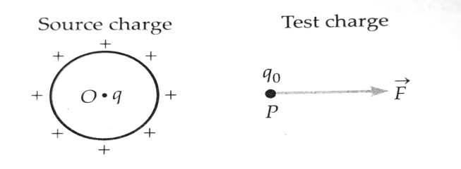

**A charged body produces an electric field around it.**

**Consider a charged body carrying a positive charge q placed at point 0. It is assumed that the charge q produces an electrical environment in the surrounding space, called electric field. To test the existence of electric field at any point P, we simply place a small positive charge q0, called the test charge at the point P. If a force of $\begin{matrix}→ \\ F \\ .\end{matrix}$ is exerted on the test charge, then we say that an electric field of $\begin{matrix}→ \\ E \\ .\end{matrix}$ exists at the point P. The charge q is called the source charge as it produces the field $\begin{matrix}→ \\ E \\ .\end{matrix}$.**

**Electric field**

**An electric field is said to exist at a point if a force of electrical origin is exerted on a stationary charged body placed at that point. Quantitatively, the electric field or the electric field intensity or the electric field strength $\begin{matrix}→ \\ E \\ .\end{matrix}$ at a point is defined as the force experienced by a unit positive test charge placed at that point, without disturbing the position of source charge.**

**As shown in above figure, suppose a test charge q0 experiences a force $\begin{matrix}→ \\ F \\ .\end{matrix}$ at the point P. Then the electric field at that point will be**

$\begin{matrix}→ \\ E \\ .\end{matrix}$**= $\frac{\begin{matrix}→ \\ F\end{matrix}}{q_{0}}$**

**There is a difficulty in defining the electric field by the above equation. The test charge q0 may disturb the charge distribution of the source charge and hence change the electric field $\begin{matrix}→ \\ E \\ .\end{matrix}$ which we want to measure. The test charge q0 must be small enough so that it does not change the value of $\begin{matrix}→ \\ E \\ .\end{matrix}$. It is better to define electric field as follows.**

**The electric field at a point is defined as the electrostatic force per unit test charge acting on a vanishingly small positive test charge placed at that point. Hence**

$\begin{matrix}→ \\ E \\ .\end{matrix}$**= $\begin{matrix}lim \\ q_{0 →0}\end{matrix}\frac{\overset{→}{F}}{q_{0}}$**

**The electric field $\begin{matrix}→ \\ E \\ .\end{matrix}$ is a vector quantity whose direction is same as that of the force $\begin{matrix}→ \\ F \\ .\end{matrix}$ exerted on a positive test charge.**

**Units and dimensions of electric field**

**As the electric field is force per unit charge, so its SI unit is Newton per coulomb (NC-1). It is equivalent to volt per meter (Vm-1 ).**

**The dimensions for $\begin{matrix}→ \\ E \\ .\end{matrix}$ can be determined as follows:**

**. $\left|E\right|$ = $\frac{force }{charge}$ = $\frac{MLT^{-2}}{C}$**

$\left|E\right|$**= $\frac{MLT^{-2}}{A . T}$ = $\left[M L T^{-3}A^{-1}\right]$ $\left[1 A= \frac{1 C}{1 s}\right]$**

**Physical significance of electric field**

**The force experienced by the test charge q0 is different at different points. So $\begin{matrix}→ \\ E \\ .\end{matrix}$ also varies from point to point. In general, $\begin{matrix}→ \\ E \\ .\end{matrix}$ is not a single vector but a set of infinite vectors. Each point $\begin{matrix}→ \\ r \\ .\end{matrix}$ is associated with a unique vector $\begin{matrix}→ \\ E ( \\ .\end{matrix}r) .$ so electric field is an example of vector field.**

**By knowing electric field at any point, we can determine the force on a charge placed at that point. The Coulomb force on a charge q0 due to a source charge q may be treated as two stage process**

**(1) The source charge q produces a definite field $\begin{matrix}→ \\ E ( \\ .\end{matrix}r)$ at every point $\begin{matrix}→ \\ r \\ .\end{matrix}$.**

**(2) The value of $\begin{matrix}→ \\ E ( \\ .\end{matrix}r)$ at any point $\begin{matrix}→ \\ r \\ .\end{matrix}$ determines the force on charge q0 at that point. This force is**

$\begin{matrix}→ \\ F \\ .\end{matrix}$**= q0 $\begin{matrix}→ \\ E \\ .\end{matrix}$**

**Electrostatic force = Charge x Electric field.**

**Thus an electric field plays an intermediary role in the forces between two charges:**

**Charge $⇌$ Electric field $⇌$ Charge**

**It is in this sense that the concept of electric field is useful. Electric field is a characteristic of the system of charges and is independent of the test charge that we place at a point to determine the field.**

**ELECTRIC FIELD DUE TO A POINT CHARGE**

**A single point charge has the simplest electric field. As shown in Figure, consider a point charge q placed at the origin 0. We wish to determine its electric field at a point P at a distance r from it. For this, imagine a test charge q0 placed at point P. According to Coulomb's law, the force on charge q0 is**

**O $\overset{→}{r}$ P**

**q•----------------------------------------------------**

**Source charge Test charge**

**Electric field of a point charge**

$\begin{matrix}→ \\ F_{.} \\ .\end{matrix}$**= $\frac{1}{4Πε_{0}}$ $\frac{qq_{0 }}{r^{2}}$ ȓ**

**Where ȓ is a unit vector in the direction from q to q0, Electric field at point P is**

$\begin{matrix}→ \\ E_{.} \\ .\end{matrix}$**= $\frac{\overset{→}{F}}{q_{o}}$ = $\frac{1}{4Πε_{0}}$ $\frac{qq_{0 }}{r^{2}}$ ȓ**

**The magnitude of the field $\begin{matrix}→ \\ E_{1} \\ .\end{matrix}$ is**

**E= $\frac{1}{4Πε_{0}}$ $\frac{q}{r^{2}}$**

**Clearly, E α $1/{r^{2}}$ this means that at all points on the spherical surface drawn around the point charge, the magnitude of $\overset{→}{E}$ is same and does not depend on the direction of $\overset{→}{r}$. Such a field is called spherically symmetric or radial field, i.e., a field which looks the same in all direction when seen from the point charge.**

**ELECTRIC FIELD DUE TO A SYSTEM OF POINT CHARGES**

**Consider a system of N point charges q1, q2, …….., qN having position vectors $\begin{matrix}→ \\ r_{1} \\ .\end{matrix}, \begin{matrix}→ \\ r_{2} \\ .\end{matrix}, …………, \begin{matrix}→ \\ r_{N} \\ .\end{matrix}$ with respect to the origin 0. We wish to determine the electric field at point P whose position vector is $\begin{matrix}→ \\ r_{.} \\ .\end{matrix}$.**

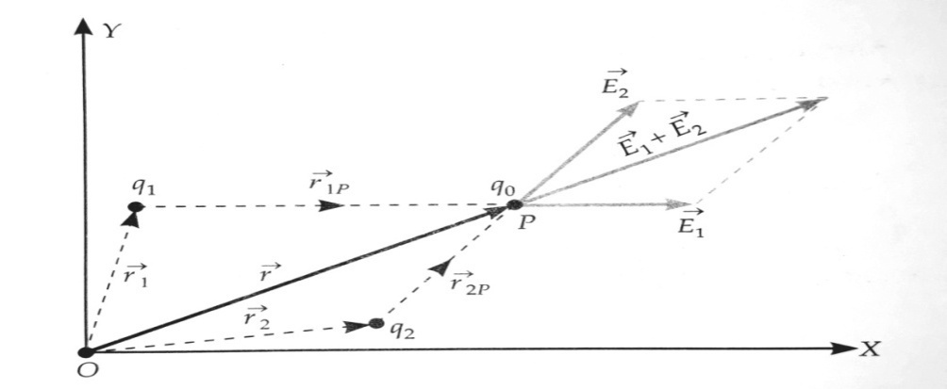 **Notations used in the determination of electric field at a point due to two point charges.**

**According to Coulomb's law, the force on charge test q0 due to charge q1 is.**

**=**

**Where $ȓ_{1p}$ a unit is is vector in the direction from q1 to P and r1p is the distance between from q1 and P. Hence the electric field at point P due to charge q1, is**

$\begin{matrix}→ \\ E_{1} \\ .\end{matrix}$**= $\frac{\overset{→}{F_{1}}}{q_{o}}$**

**= $\frac{1}{4Πε_{0}}$ $\frac{q_{1}}{{r_{1p}}^{2}}$ $ȓ_{1p}$**

**Similarly, electric field at P due to charge q2 is**

$\begin{matrix}→ \\ E_{2} \\ .\end{matrix}$**= $\frac{1}{4Πε_{0}}$ $\frac{q_{2}}{{r_{2p}}^{2}}$ $ȓ_{2p}$**

**According to principle of superposition of electric fields, the electric field at any point due to a group of charges is equal to the vector sum of the electric fields produced by each charge individually at that point, when all other charges are assumed to be absent.**

**Hence, the electric field at point P due to the system of N charges is**

$\begin{matrix}→ \\ E_{.} \\ .\end{matrix}$**= $\begin{matrix}→ \\ E_{1} \\ .\end{matrix}$ + $\begin{matrix}→ \\ E_{2} \\ .\end{matrix}$ +………….+ $\begin{matrix}→ \\ E_{N} \\ .\end{matrix}$**

$\begin{matrix}→ \\ E_{.} \\ .\end{matrix}$**= $\frac{1}{4Πε_{0}}$ $\left[ \frac{q_{1}}{{r_{1p}}^{2}}ȓ_{1p}+\frac{q_{2}}{{r_{2p}}^{2}}ȓ_{2p}+ ………………+\frac{q_{N}}{{r_{Np}}^{2}}ȓ_{NP}\right]$**

**Or $\begin{matrix}→ \\ E_{.} \\ .\end{matrix}$ = $\frac{1}{4Πε_{0}}\sum_{i=1}^{N}{ \frac{q_{i}}{{r_{ip}}^{2}} ȓ_{ip}}$**

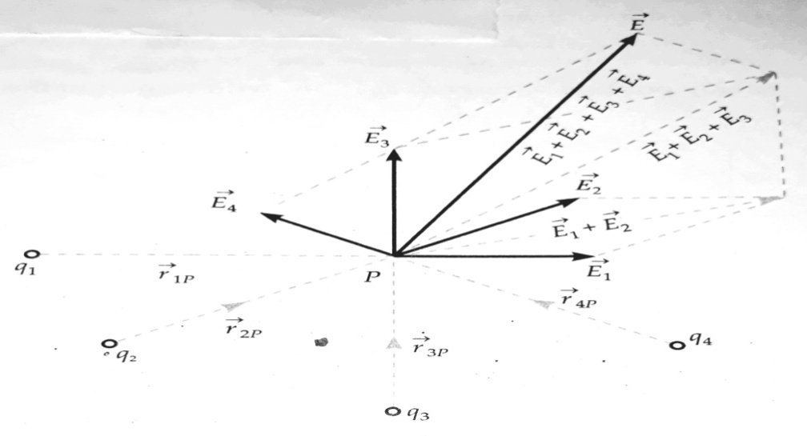

**(Electric field at a point due to a system of charges is the vector sum of the electric fields at the point due to individual charges)**

**In terms of position vectors, we can write**

$\begin{matrix}→ \\ E_{.} \\ .\end{matrix}$**= $\frac{1}{4Πε_{0}}\sum_{i=1}^{N}{ \frac{q_{i } }{\begin{matrix}\overset{→}{|r} & - & \overset{→}{r_{i| }2}\end{matrix}} \frac{\begin{matrix}\overset{→}{r} & - & \overset{→}{r_{i}}\end{matrix}}{\begin{matrix}\overset{→}{r} & - & \overset{→}{r_{i}}\end{matrix}} }$**

**Or $\begin{matrix}→ \\ E_{.} \\ .\end{matrix}$ = $\frac{1}{4Πε_{0}}\sum_{i=1}^{N}{ \frac{q_{i } }{\begin{matrix}\overset{→}{|r} & - & \overset{→}{r_{i| }3}\end{matrix}} (\begin{matrix}\overset{→}{r} & - & \overset{→}{r_{i})}\end{matrix}. }$**